Chapter 5, Problem 23

For the op amp circuit in Fig. 5.61, find the voltage gain v_{o}/v_{s}.

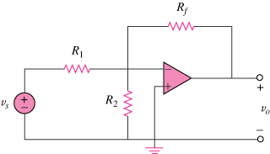

Figure 5.61
For Prob. 5.23.

